The Chorus Chronicles · Book One
Serenade of the Sasquatch
Classroom Kit
A complete teaching kit for grades 6–8
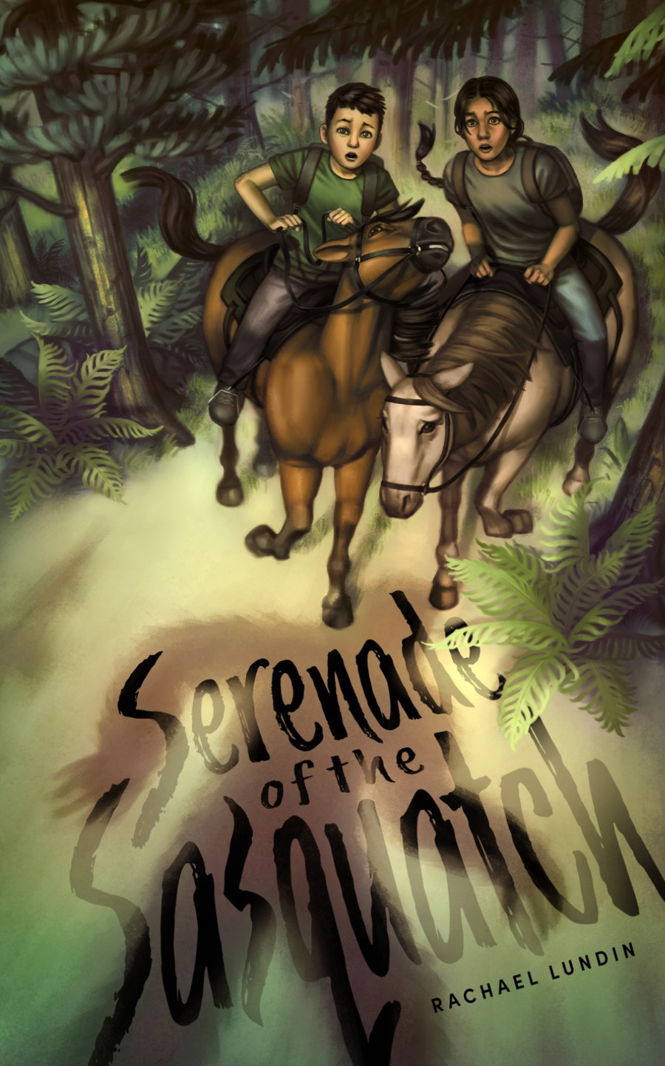

Everything you need to take your class into the Cascade Mountains on an expedition of mystery, evidence, and Bigfoot, paced to fit your class in three to five weeks, built for middle-school ELA, and ready to copy.
by Rachael Lundin

What’s Inside
 | Teacher’s Guide FOR TEACHERS  Book overview, learning objectives, pacing, section-by-section teaching notes with answer keys and lesson ideas, content notes, and a standards chart
 | Student Field Journal FOR STUDENTS  Vocabulary, reading questions, writing prompts, and research tools for each of the six reading sections
 | Assessment Packet FOR STUDENTS  Six one-page section quizzes and a final project with five choices, scored on one rubric
 | Family Letter FOR FAMILIES  A one-page introduction to the book, a gentle content heads-up, and dinner-table questions
 | Author and Series One-Sheet FOR TEACHERS AND FAMILIES  About the author, the Chorus Chronicles series, school visits, and ordering

Getting Started
- Read the Teacher’s Guide overview and content notes, and preview Chapter 27 before assigning it.
- Send the Family Letter home about a week before you begin.
- Hand out the Student Field Journal on day one, and set up the three research tools together.
- Give each section quiz after students finish that reading section.
- Introduce the final project in Lesson 8, about halfway through the book, so students have time to plan.
- Share the Author and Series One-Sheet if you’d like to book a visit or point readers to Book 2.

Ready to Adapt for Every Student
Every document in this kit comes as an editable Word file, so you can adapt it for your students. Enlarge the text, add writing space, trim or simplify questions, or use your school’s read-aloud tools. Pages are designed in black and white to copy cleanly.

Questions?
Contact Rachael Lundin at rachael@rachaellundin.com or visit rachaellundin.com.
© 2026 Rachael Lundin. This kit is free, and pages may be copied for classroom use.

