MEET THE AUTHOR
Rachael Lundin
Author of the Chorus Chronicles

 | About the Author  Rachael Lundin writes adventure stories because she lives them. She has ridden 700 kilometers across Mongolia’s Gobi Desert, biked through southern France, volunteered in Tanzania, and helped build a children’s camp in Brazil. Her memoir, Mongolian Love Letters, tells the story of her Gobi ride.  Rachael lives in Wenatchee, Washington, just down the road from the Leavenworth mountains where Dakota and Sidney meet their Bigfoot. For more than 20 years she has worked for Washington State, and today she specializes in making online learning accessible to everyone.
The Chorus Chronicles
A planned three-book series about Dakota Geske, his best friend Sidney, and the hidden creatures who share our world, each with a song of its own.
  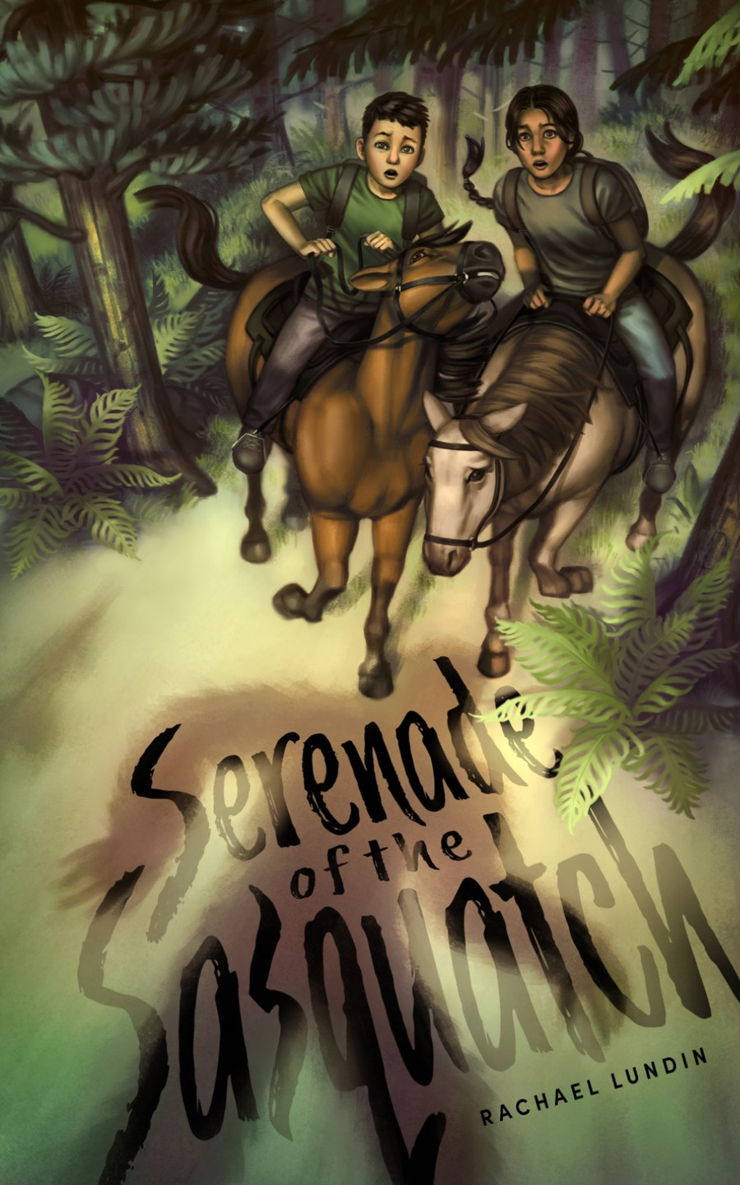 | Serenade of the Sasquatch  BOOK 1 · IDYLL ARBOR, 2024  A horseback ride into the Cascades leads Dakota and Sidney to an abandoned cabin, a hidden journal, a 20-year-old mystery, and a young Bigfoot named River on a quest of his own.
  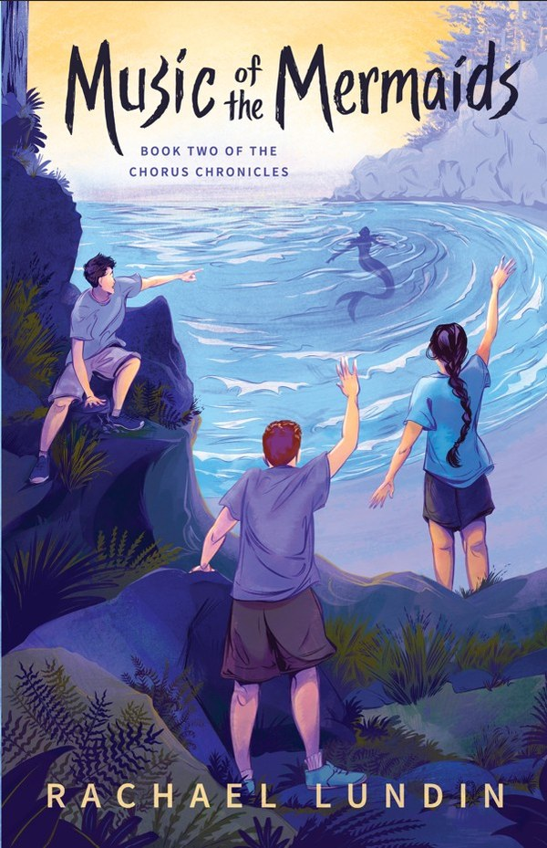 | Music of the Mermaids  BOOK 2 · IDYLL ARBOR, NOVEMBER 1, 2026  Summer takes Dakota and Sidney to the coastal town of Ilwaco, Washington. Remember the book on mermaids in Dakota’s mom’s attic? The ocean has its own secrets, and its own songs.
 | FREE CLASSROOM KIT Teaching Serenade of the Sasquatch in grades 6–8? A free kit includes a Teacher’s Guide, Student Field Journal, quizzes and a final project, and a family letter. Download it free at rachaellundin.com/for-teachers.
Invite Rachael to Your Classroom
Rachael visits schools in person across North Central Washington and virtually anywhere. Each visit can be tailored to your grade and schedule.
Program | What students get | Length
Behind the Bigfoot | The story behind the story: where the idea for the book came from, plus Q&A | 45 minutes
Two Sides of the Story | A writing workshop on point of view: students rewrite a scene as River | 60 minutes
Adventures of a Writer | Stories and photos from the Gobi Desert and beyond, and how adventure feeds writing | 45 minutes
To book a visit: contact Rachael at rachaellundin.com with your school, grade level, preferred dates, and whether you’d like an in-person or virtual visit.
Signed books: Families can pre-order signed copies for $10 each. Rachael provides an order form to send home before the visit and brings the signed books on visit day.
Ordering Books
Title | Publisher | ISBN | Formats
Serenade of the Sasquatch | Idyll Arbor | 978-093-199-0106 | Paperback, ebook
Music of the Mermaids | Idyll Arbor | 978-093-199-0144 | Paperback, ebook
Classroom sets: contact Idyll Arbor at orders@idyllarbor.com

